**Paidy payment processing SFRA**

Version<22.1.1>



# Table of contents

Detailes

Table of contents 2

1. Summary 4

2.Component summary 5

2-1. Features overview 5

2-2. Restrictions and limitations 5

2-3. Use cases 6

2-3-1. Standard payments 6

2-3-2. Subscription payments 9

2-4．Privacy when paying 13

3. Implementation guide 14

3-1．Uploading cartridges (UX Studio) 14

3-2．BusinessManager setup 14

3-2-1. Cartridge assignment 14

3-2-2. Importing metadata 16

3-3．Modifying cartridges on the merchant 20

3-3-1. Add payment method 20

3-3-2. CheckoutJS installation 25

3-3-3. Added paidy.js loading 25

3-3-4. Add attribute on order confirmation button 26

3-3-5. CheckoutServices.js modifications 26

3-3-6. Add payment method to email template 30

3-4. Advice 31

4. Cartridge deployment testing at merchant 33

4-1. Before beginning a test 33

4-1-1. Paidy merchant dashboard screen 33

4-1-2.Commerce Cloud Business Manager 34

4-2. PaidyCheckout test data 34

4-3. Browser compatibility 35

4-4. Test cases 35

4-4-1. Paidy standard payments 35

4-4-2. Paidy subscription payments 36

5. Webhook usage examples 37

5-1. Webhook usage 37

5-2. Detecting inconsistent payments 37

5-3. Handling inconsistencies 38

5-3-1. Processing example 1 38

5-3-2. Processing example 2 41

5-4. Webhook settings 41

6. What to do when the service is down 42

7. Revision history 43

# 1. Summary

This implementation guide supports Store Front Reference Architecture (SFRA 6.1.0) .

Compatibility Mode up to 22.7 is supported.

Cartridges allow a Commerce Cloud store to make use of Paidy payments.

The developer must follow this text to install the cartridges and set them up on the online store.

Because Paidy allows for creating test payments by making use of a test API key, the user can test the settings before switching over to a live environment. For details on data needed for testing, see 4-1. Before beginning a test.

A cartridges must be implemented in order to begin using Paidy payments.

・”int_paidy_sfra” is the core cartridge that enables use of Paidy payments on the store.

*Other cartridges are used on SiteGenesis based cartridges.

# 2.Component summary

## 2-1. Features overview

The process flow for Paidy is explained in the diagram below.

Paidy cartridges correspond to point 1-6 in this workflow.

In step 1-6, the results of authentication with Paidy are saved on the site.

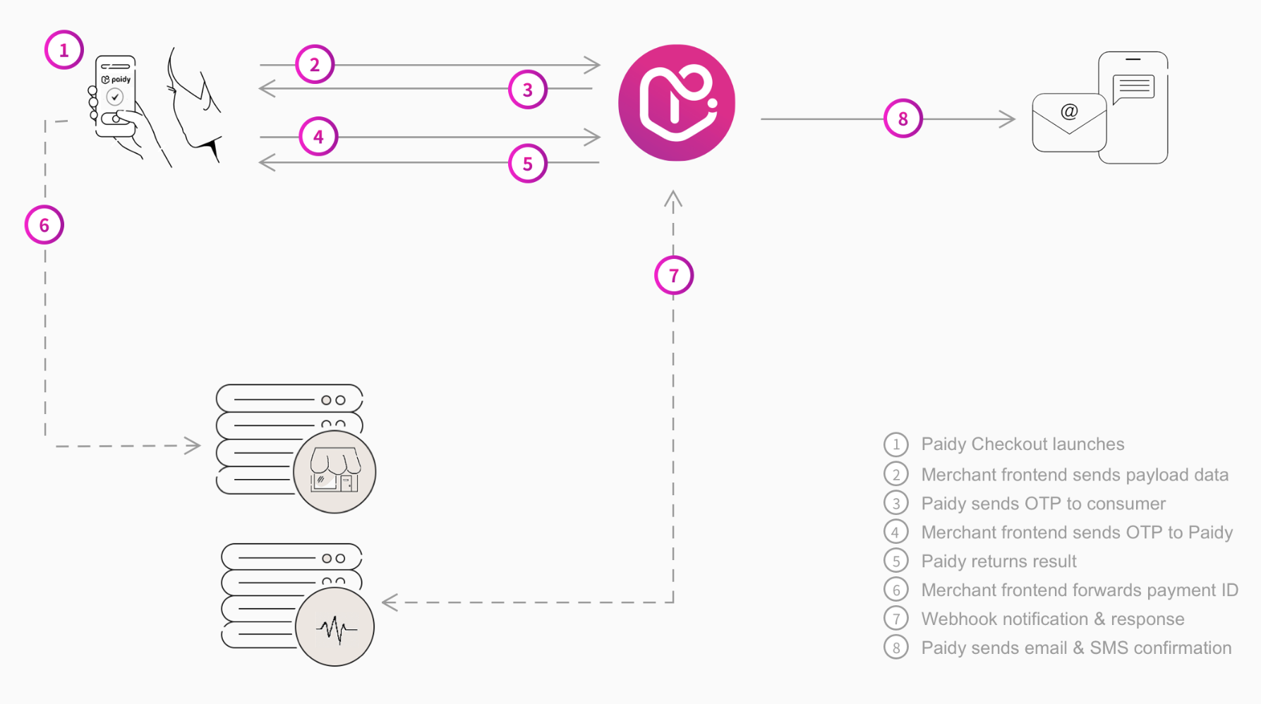

## 2-2. Restrictions and limitations

- Only a “creation” process is in place for payment. Capture, Refund, Update, and Close must be implemented by the merchant.

- For first-time subscription payments, Commerce Cloud runs a creation process.

　Subsequent payments must be configured at the merchant, but the payment process can be implemented by executing the functions found in the Paidy cartridge.

- Subscription payments are designed to only work when the user is logged in.

- Confirm notifications from the Webhook on OMS; if the payment process results are incorrect, you can choose to set the order status to shippable in SFCC, or cancel the payment on Paidy. For details, please see 5. Webhook usage examples.

- This cartridge can only be used on Japanese language sites. (language: Japanese; currency: JPY)

## 2-3. Use cases

### 2-3-1. Standard payments

　Paidy Checkout launches when a user clicks a payment purchase button on a site.

　Consumers enter the requisite information and make a Paidy payment.

　If the payment is successful, the process transitions to the product purchase confirmation screen.

- Payment flow

Select Paidy standard payments when selecting a payment method when checking out and proceed to confirming the order.

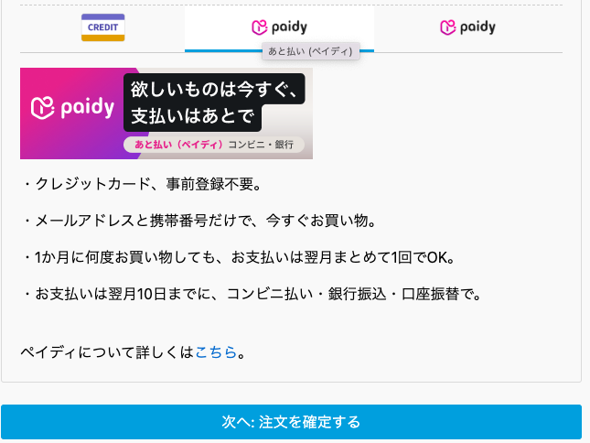

The Paidy Checkout popup appears.

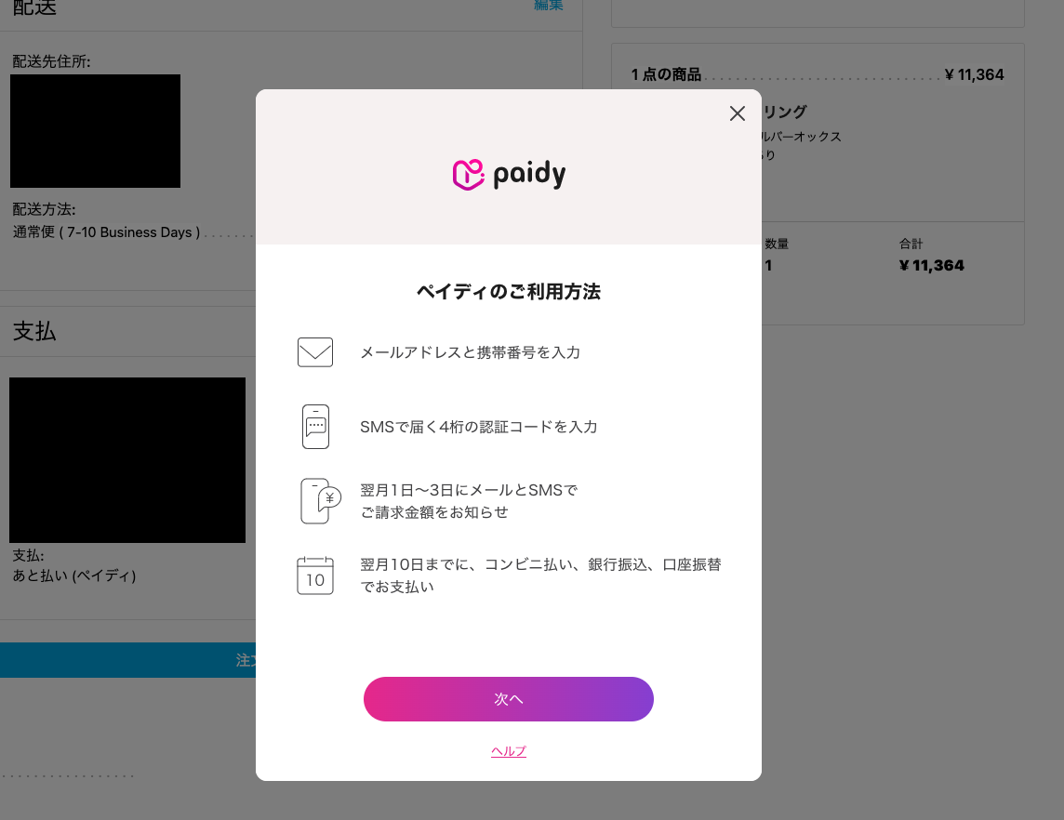

The requisite information is filled in and Paidy payment is processed.

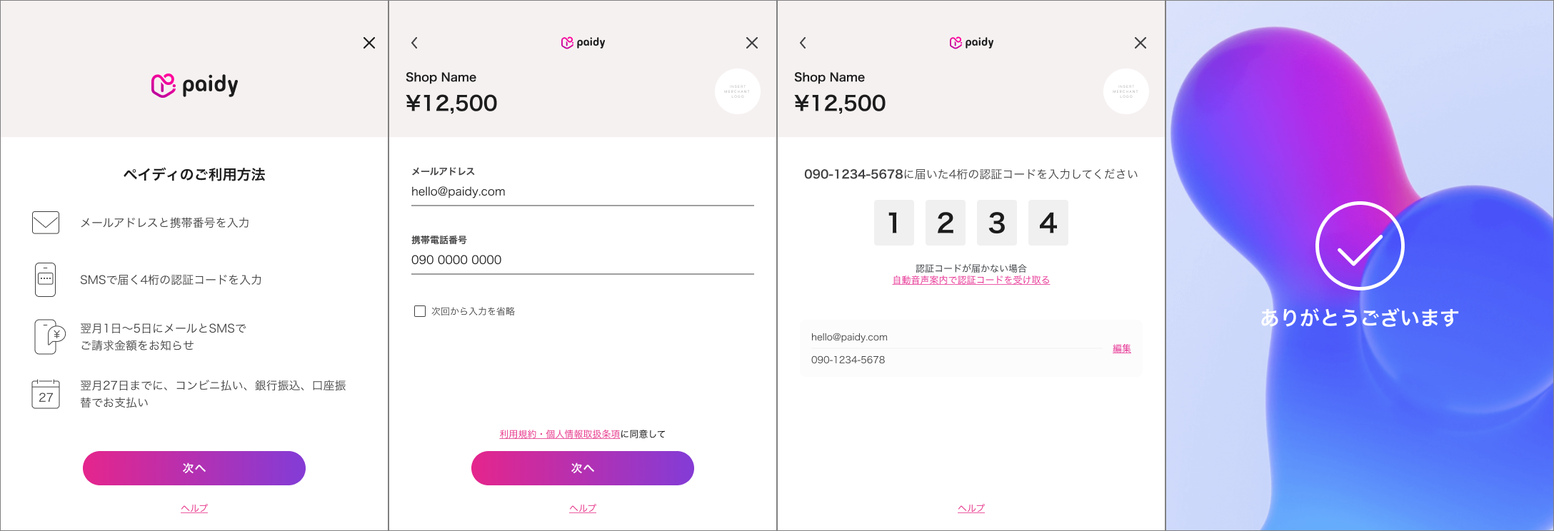

If the payment succeeds, the order is complete.

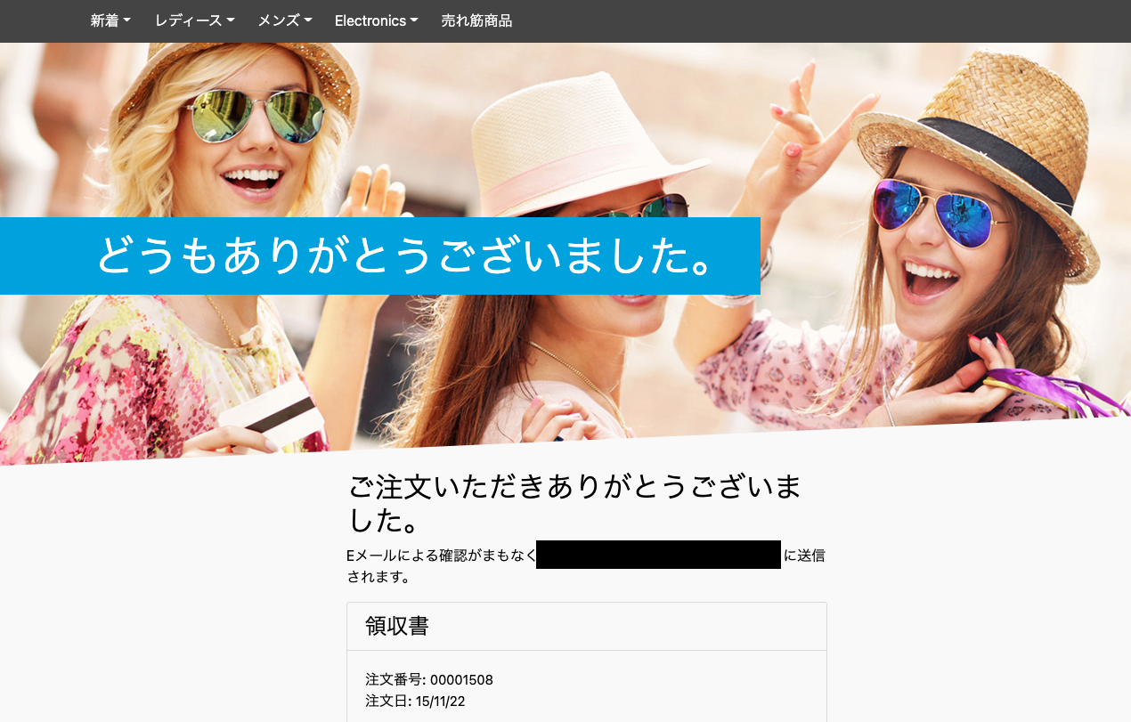

Order data created on Commerce Cloud

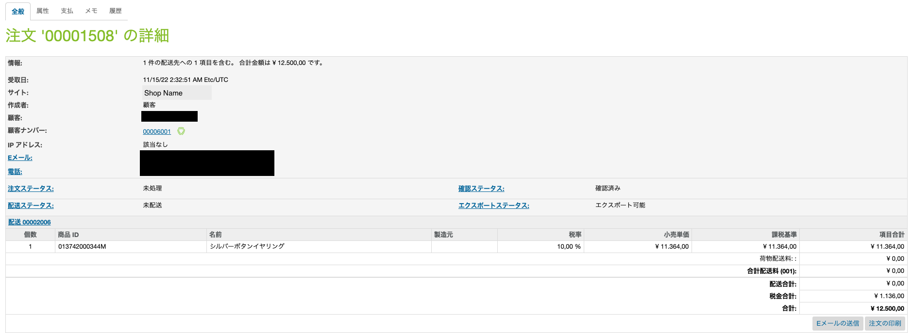

Payment data created on Paidy

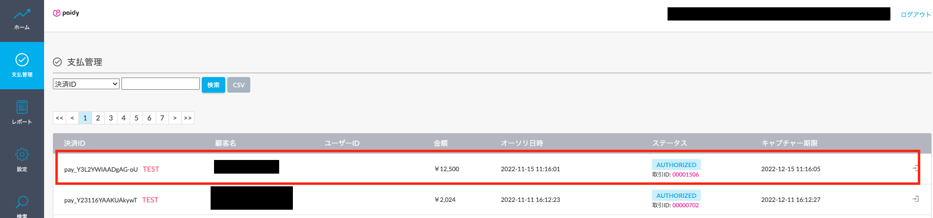

If the payment fails, Paidy Checkout displays a payment error message and order failure data is created on Commerce Cloud.

Payment data will not be created on Paidy.

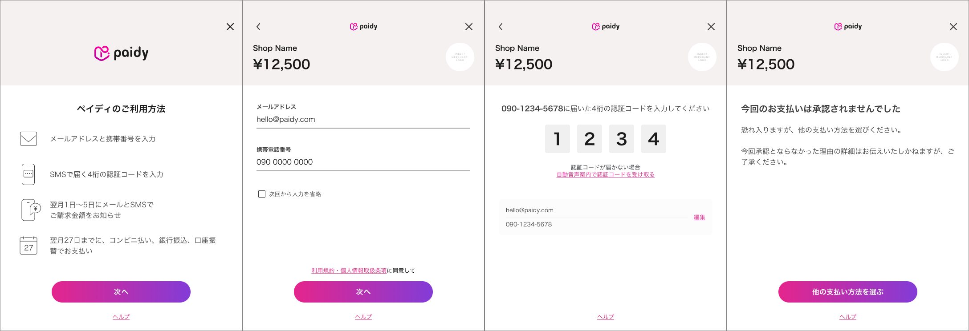

*Note that if the top-right X button is clicked on the popup, order failure data is created. Payment data will not be created on Paidy.

Order data created on Commerce Cloud (order failure)

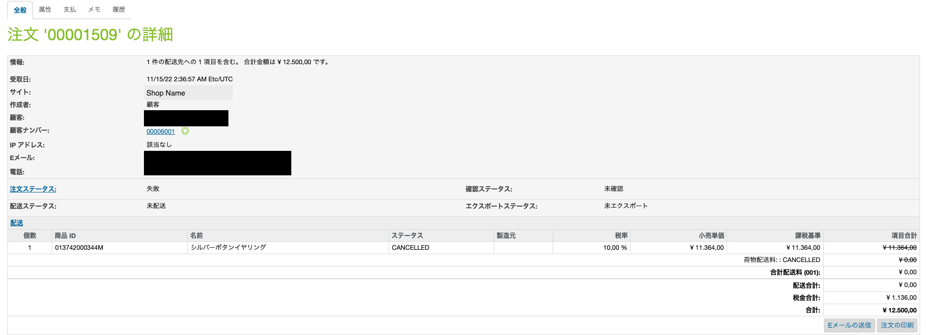

### 2-3-2. Subscription payments

　Only usable by logged in users.

　When clicking on the order confirmation button, Paidy Checkout launches. Consumers enter the requisite information and authenticate with Paidy. If the authentication completes correctly, a token is issued and is assigned to the order.

- Payment flow

Select Paidy subscription payments when selecting a payment method when checking out and proceed to confirming the order.

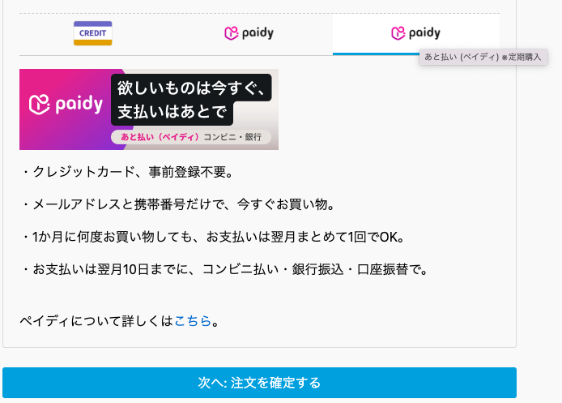

An order confirmation screen is displayed and the order is confirmed.

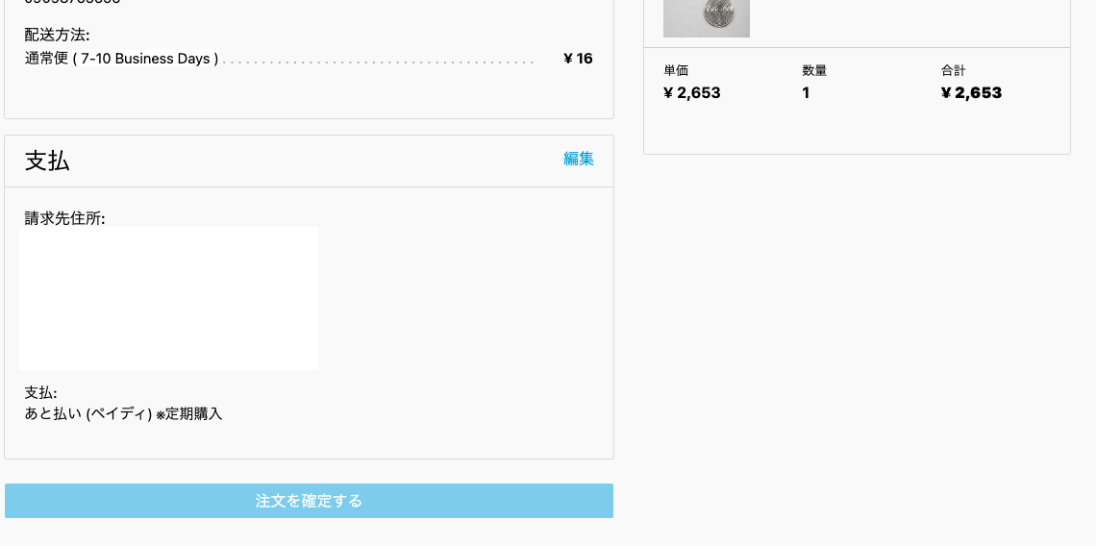

The Paidy Checkout popup appears.

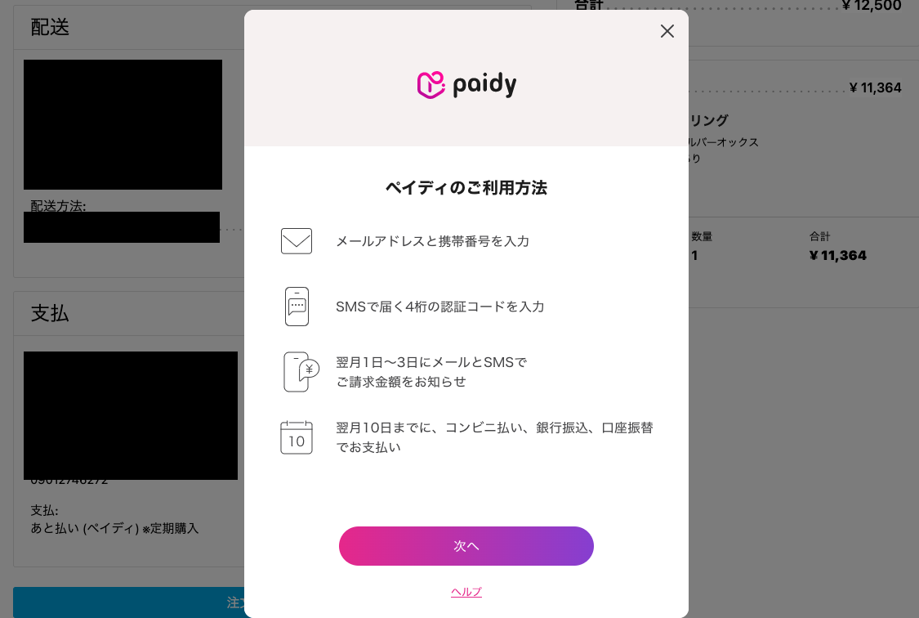

Enter the requisite information on Paidy Checkout and a token is issued.

*If the popup is closed during the process by the user clicking the X button on the top right, the popup will no longer display, but a token can be reissued and the payment processed.

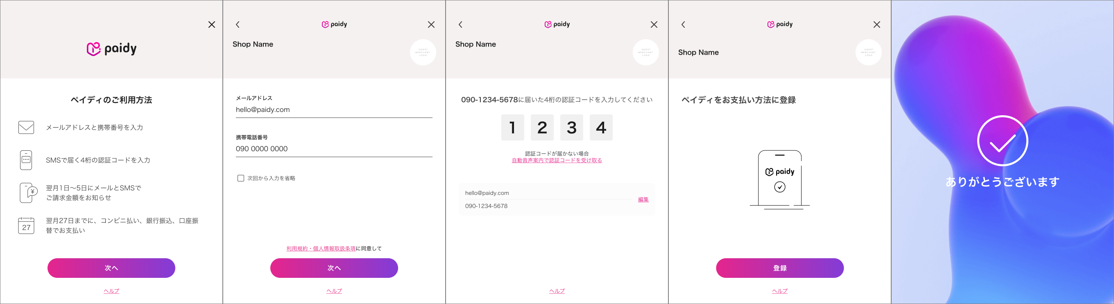

After issuing a token, the process moves to payment processing. If the payment succeeds, we transition to the order confirmation screen. 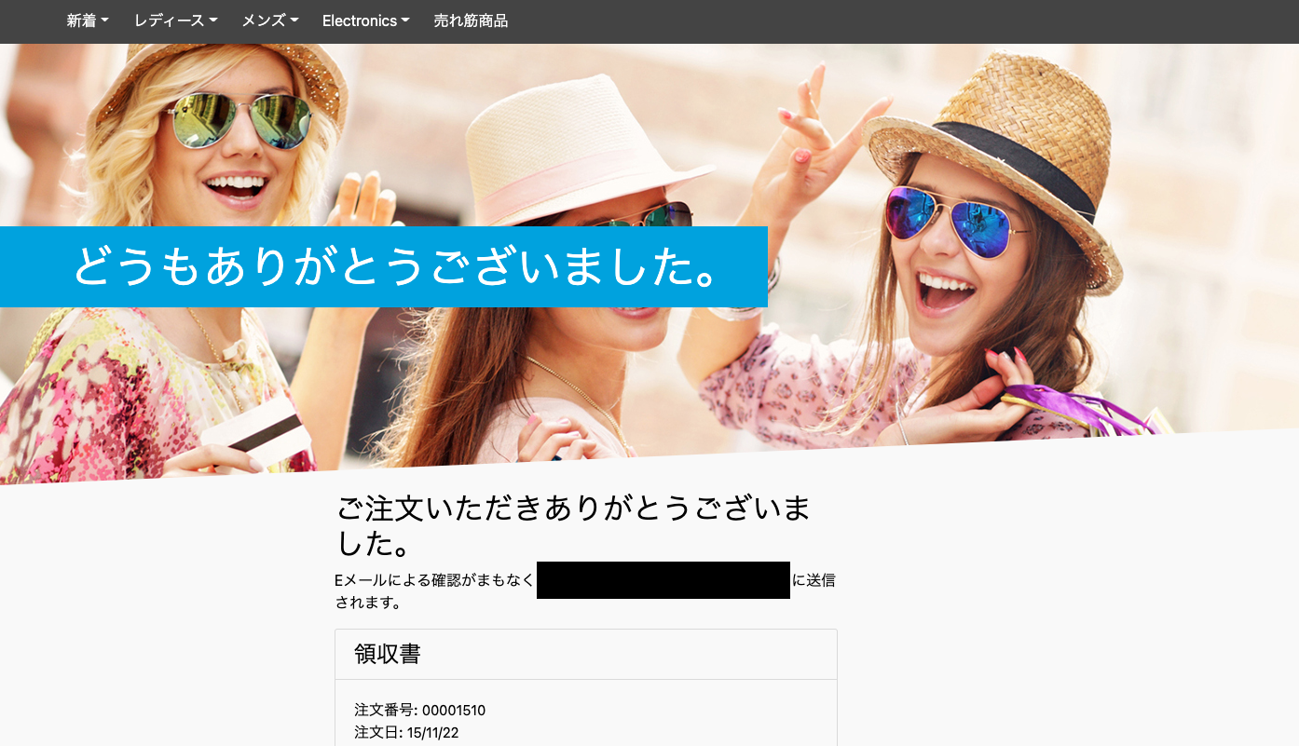

Order data created on Commerce Cloud

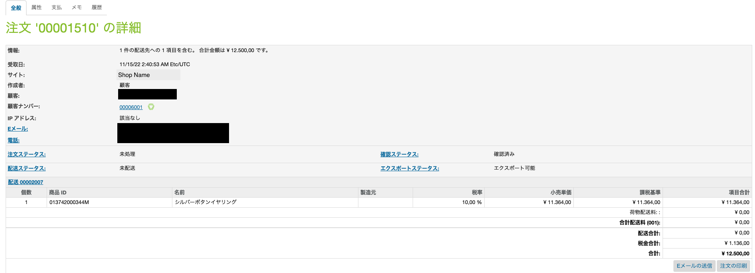

Payment data created on Paidy

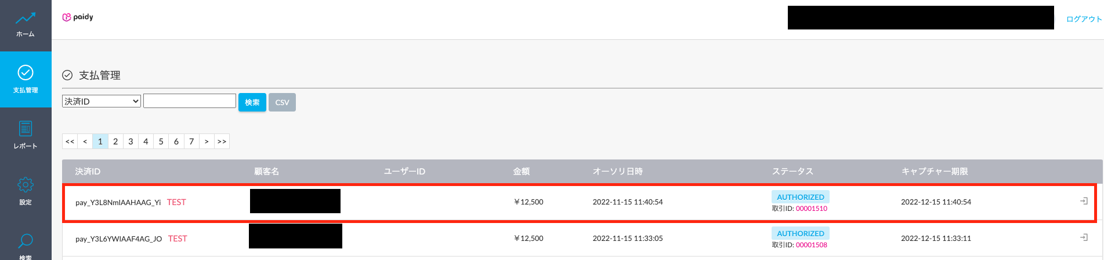

If payment fails, a payment error will be displayed on the order confirmation page and order failure data is created on Commerce Cloud.

Payment data will not be created on Paidy.

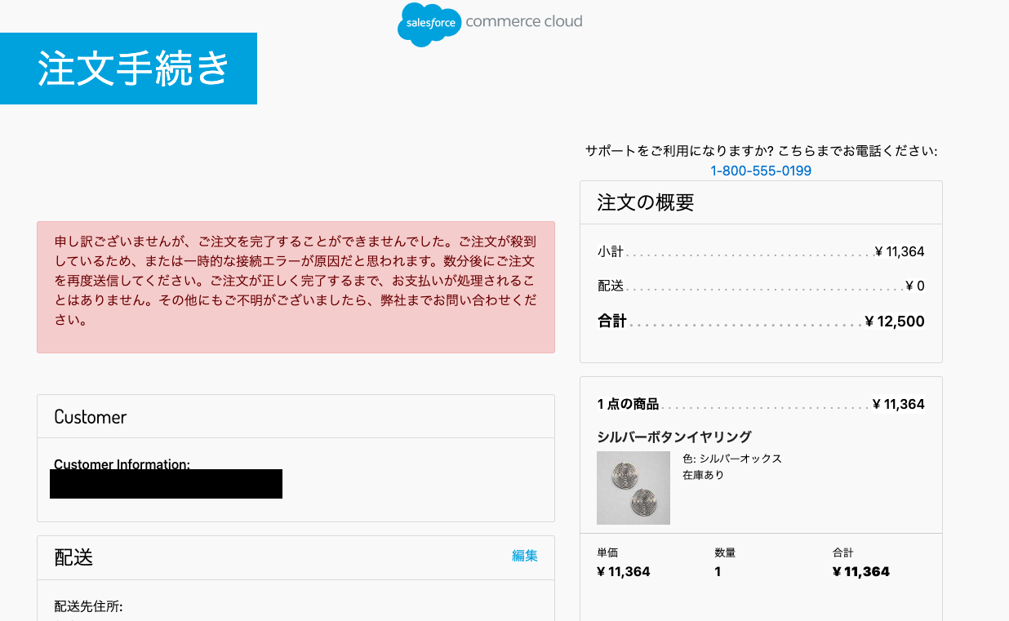

Order data created on Commerce Cloud (order failure)

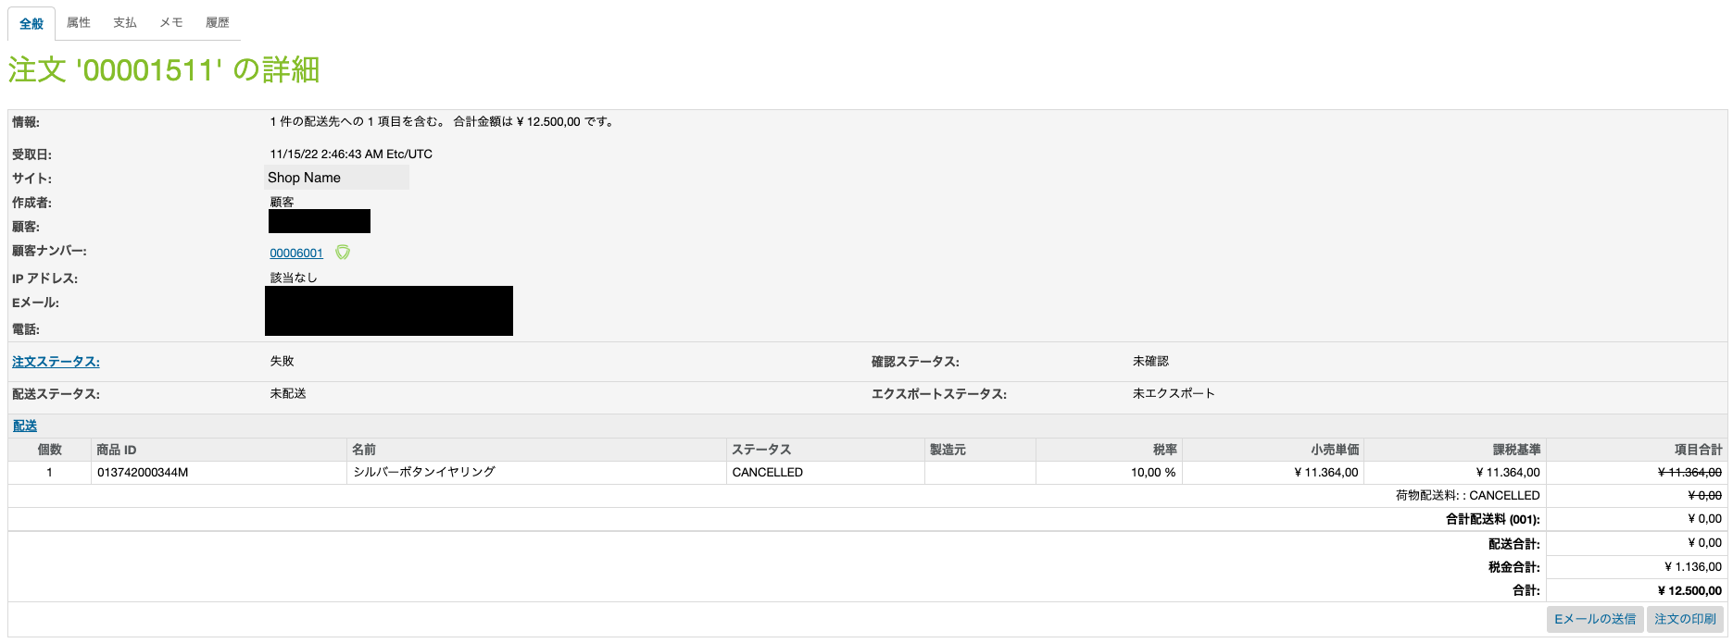

## 2-4．Privacy when paying

Paidy payment authentication requires entering a telephone number and e-mail address, but these are not saved on Commerce Cloud.

However, information entered upon registration and shipment and billing details are saved on Commerce Cloud.

# 3. Implementation guide

## 3-1．Uploading cartridges (UX Studio)

The cartridge is uploaded to Commerce Cloud.

・int_paidy

・int_paidy_sfra

The cartridge is for Store Front Reference Architecture (SFRA).

*If your website is based SiteGenesis, please refer to SiteGenesis implementation guide.

Use Commerce Cloud UX-studio to upload the int_paidy and int_paidy_sfra cartridges to Commerce Cloud.

## 3-2．BusinessManager setup

Paidy payment settings are configured on the Commerce Cloud management screen (Business Manager).

### 3-2-1. Cartridge assignment

A Paidy cartridge is assigned to the site.

Management > Sites > Site Management > Sites Under Management: Settings

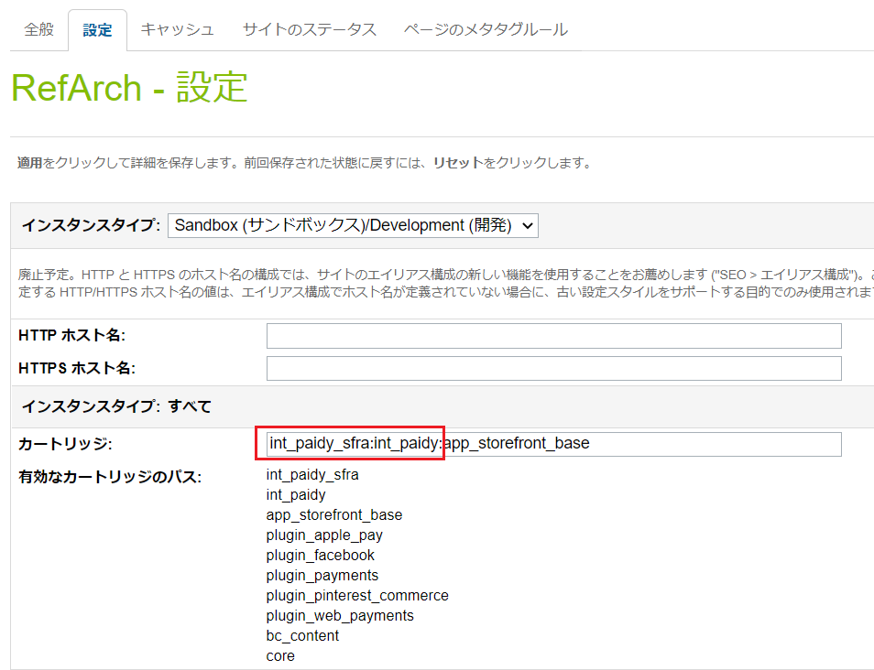

int_paidy_sfra:int_paidy:merchant cartridge

### 3-2-2. Importing metadata

Meta_data_22.1.0.zip is provided in the package.

By importing this zip file, you can add services, add payment methods / payment processors, change system objects and custom objects to use Paidy payment. Details will be described later.

Administration > Site Development > Site Import & Export

Click [Choose File].

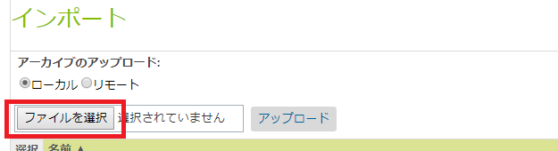

Select meta_data_22.1.0.zip in the package and click the [Upload] button.

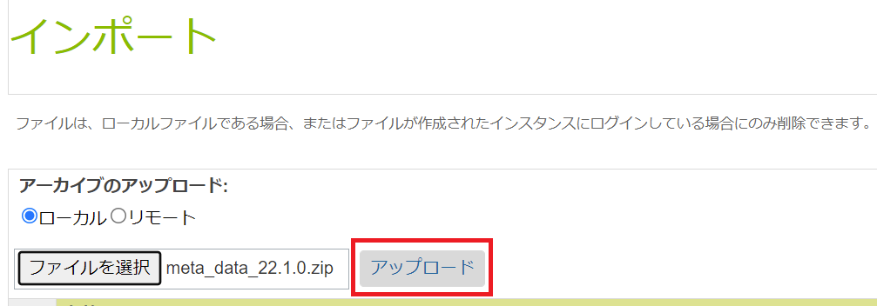

After uploading the zip file, check meta_data_22.1.0.zip and click [Import].

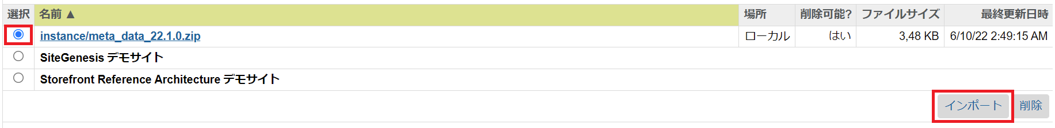

Click [OK].



-Configuration when importing service metadata

Describes the service configuration when importing metadata.

Note that for services added after import

Please do not change the information described.

< Service Credentials >

Name：paidy.http.payment

URL：https://api.paidy.com

< Service Profiles >

Name：paidy.api.prof

< Services >

Name：paidy.api.payment

Type：HTTP

Enabled：check on

Service Mode：Live

Profile：paidy.api.prof

Credentials：paidy.http.payment

· Payment method · Configuration when importing payment processor metadata

Describes the payment method and payment processor configuration when metadata is imported.

As a point of caution, for payment methods and payment processors added after import

Please do not change the information described.

<Payment Processors >

ID：PAIDY_STANDARD

<Payment Processors >

ID：PAIDY_SUBSCRIPTION

< Payment Methods >

ID：PAIDY_STANDARD

Name：あと払い（ペイディ）

Enabled：Yes

< Payment Methods >

ID：PAIDY_ SUBSCRIPTION

Name：あと払い（ペイディ））※定期購入

Enabled：Yes

- Object layout for metadata importing

Here we include instructions on the layout of objects when importing metadata.

One word of caution is that system and custom objects added after importing should not be modified.

<Order>

Management > Site Development > System Object Types> Order - Attribute Definitions

System objects: Order is an object that corresponds to order data

Order is given the below definitions as custom attributes.

paidyPaymentId: saves the ID issued when making a Paidy payment.

paidyToken: saves the token value used when using subscription payments.

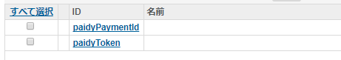

<Site Preferences>

Management > Site Development > System Object Types > Site Preferences > Attribute Definitions

System object: Site Preferences is an object that corresponds to site settings.

The below is defined as a custom attribute in Site Preferences.

paidy_api_key: public key data used to connect to the Paidy API.

　　　　　　　 This can be confirmed on the Paidy merchant management screen.

　　　　　　　For a test, save the public key used for testing purposes.

paidy_enabled: Set to use or not use Paidy cartridges.

　　　　　　　　If turn it off, paidy payments will not be available as a payment method.

paidy_logo_url: the URL of a logo image to be displayed on the Paidy Checkout application.

　　　　　　　　If nothing is set, the Paidy logo will be shown.

paidy_secret_key: secret key data used to connect to the Paidy API.

　　　　　　　　 This can be confirmed on the Paidy merchant management screen.

　　　　　　　　 When testing, save the secret key used for testing purposes.

- Paidy merchant management screen (details found in section 4-1-1)

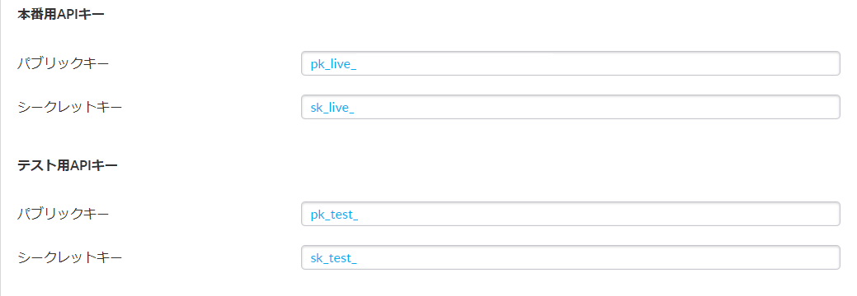

paidy_service_name: key data used to call the information for communicating with Paidy as registered in BM.

　　　　　　　　　　This is fixed to paidy.api.payment.

paidy_store_name: the shop name displayed on Paidy Checkout application headers, MyPaidy, and the merchant dashboard.

paidy_token_description (optional): specifies descriptions of tokens defined by the merchant.

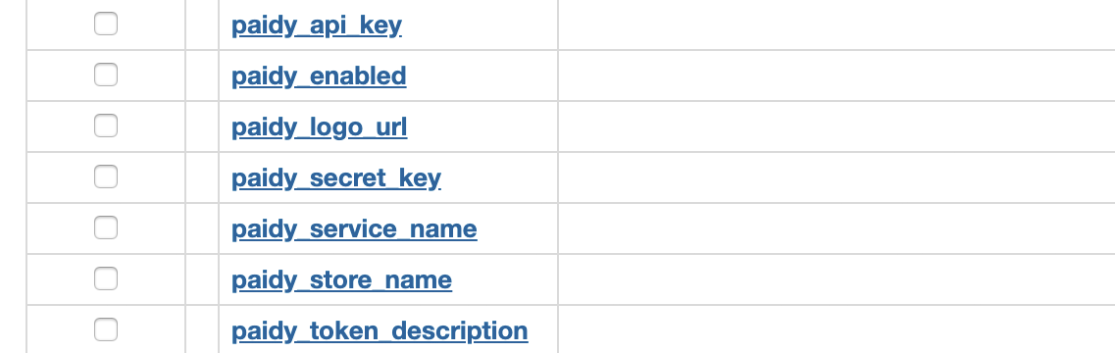

<Customer Profile>

Management > Site Development > System Object Types > Customer Profile > Attribute Definitions

System object: Customer Profile is an object relating to customer data.

The below is defined as a custom attribute on the Customer Profile.

paidyToken: token data used for subscription payments. Saved when issuing a token.

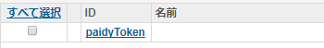

<Custom site environment settings>

Merchant Tools > Site Environment Settings > Custom Site Environment Settings Group

Once metadata is successfully imported, a group with the Paidy ID will be created in the custom environment settings group.

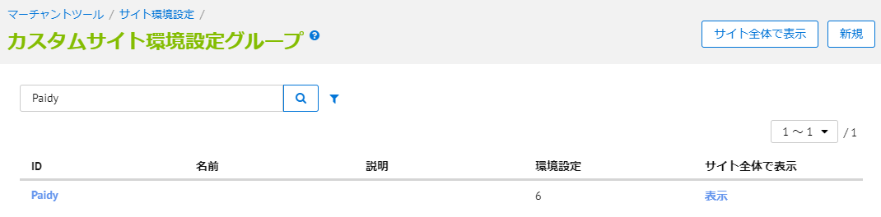

Clicking Paidy displays configuration screens for each value. Enter the requisite information and click the Save button at the top right.

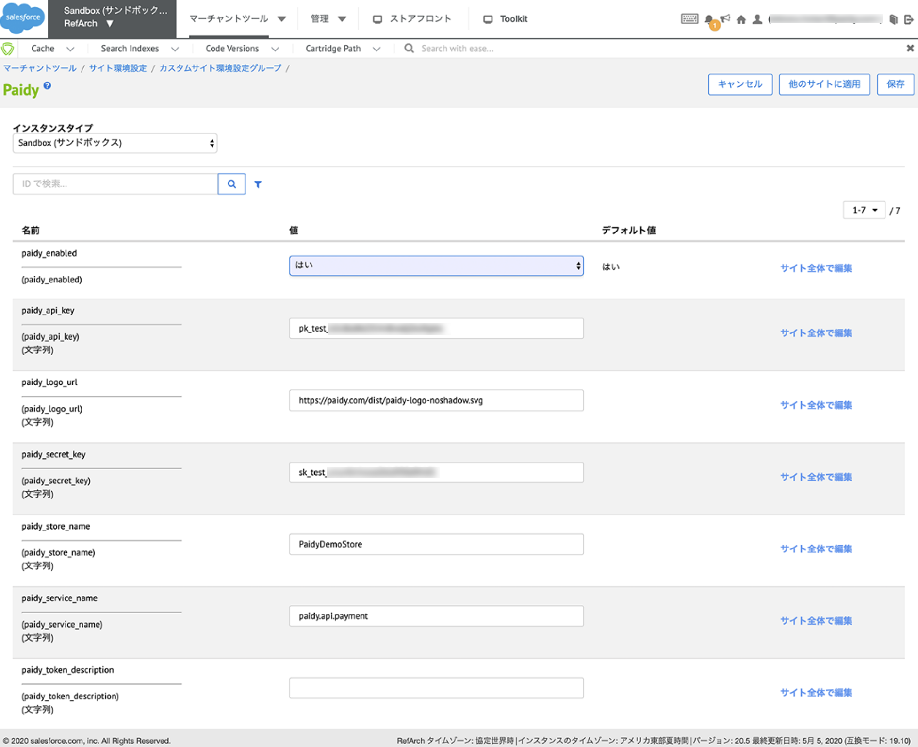

## 3-3．Modifying cartridges on the merchant

### 3-3-1. Add payment method

In order to display Paidy by payment method, write it in the template of the payment page.

By writing this script, you can:

・Selection tab added to payment methods

・The explanation for consumers is displayed when Paidy payment is selected

・Tthe type of Paidy payment selected by the payment method is displayed on the order confirmation screen when selecting Paidy payment.

To embed a template, modify the following file.

・[app_storefront_base]/cartridge/templates/default/checkout/billing/paymentOptions/paymentOptionsTabs.isml

Add the below after </isif>.

...........................

**<isif condition="${paymentOption.ID === 'PAIDY_STANDARD'}">**

**<isinclude template="checkout/billing/paymentOptions/paidyStandardTab" />**

**</isif>**

**<isif condition="${paymentOption.ID === 'PAIDY_SUBSCRIPTION'}">**

**<isinclude template="checkout/billing/paymentOptions/paidySubscriptionTab" />**

**</isif>**

...........................

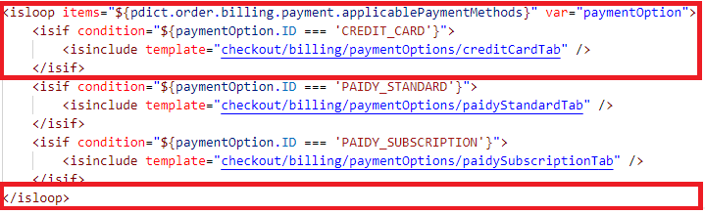

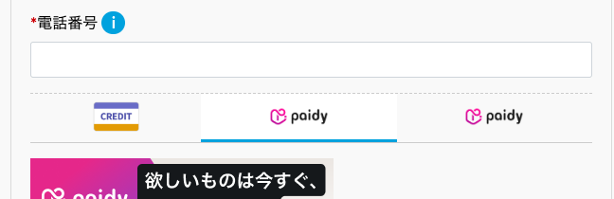

・[app_storefront_base]/cartridge/templates/default/checkout/billing/paymentOptions/paymentOptionsContent.isml

Add the below after </isif>.

...........................

**<isif condition="${paymentOption.ID === 'PAIDY_STANDARD'}">**

**<isinclude template="checkout/billing/paymentOptions/paidyStandardContent" />**

**</isif>**

**<isif condition="${paymentOption.ID === 'PAIDY_SUBSCRIPTION'}">**

**<isinclude template="checkout/billing/paymentOptions/paidySubscriptionContent" />**

**</isif>**

...........................

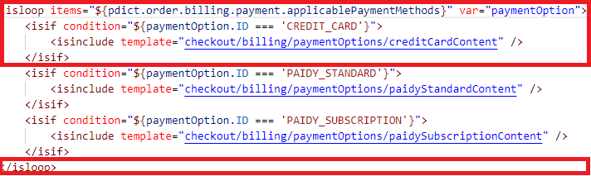

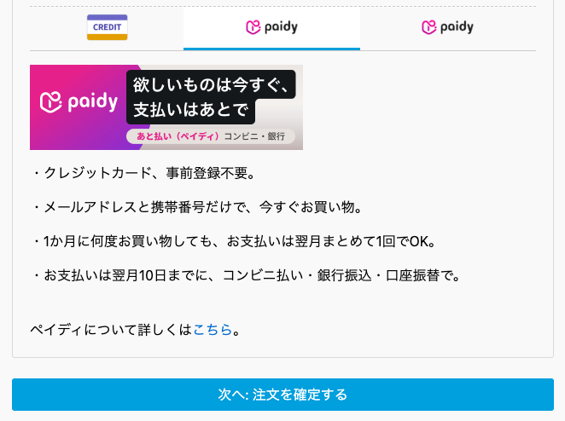

・[app_storefront_base]/cartridge/templates/default/checkout/billing/paymentOptions/paymentOptionsSummary.isml

Add the below after </isif> and </div>.

...........................

(omission)

<isif condition="${payment.paymentMethod === 'CREDIT_CARD'}">

<isinclude template="checkout/billing/paymentOptions/creditCardSummary" />

</isif>

**<isif condition="${payment.paymentMethod === 'PAIDY_STANDARD'}">**

**<isinclude template="checkout/billing/paymentOptions/paidyStandardSummary" />**

**</isif>**

**<isif condition="${payment.paymentMethod === 'PAIDY_SUBSCRIPTION'}">**

**<isinclude template="checkout/billing/paymentOptions/paidySubscriptionSummary" />**

**</isif>**

</isloop>

</div>

**<div class="payment-details-summary paidy-standard" style="display: none;">**

**<isinclude template="checkout/billing/paymentOptions/paidyStandardSummary" />**

**</div>**

**<div class="payment-details-summary paidy-subscription" style="display: none;">**

**<isinclude template="checkout/billing/paymentOptions/paidySubscriptionSummary" />**

**</div>**

...........................

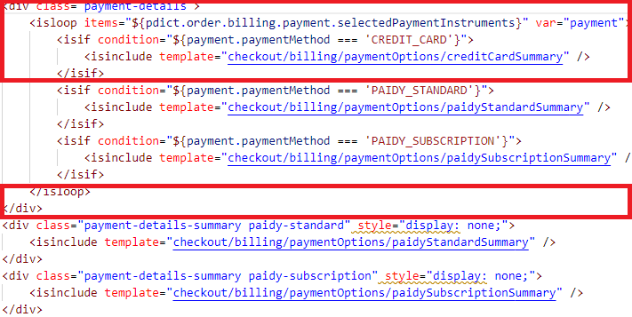

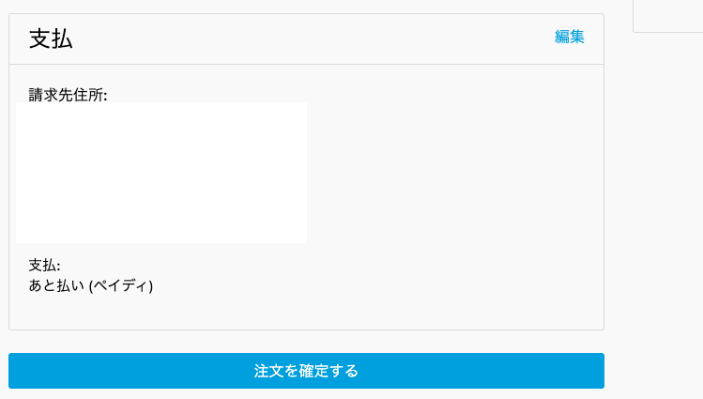

・[app_storefront_base]/cartridge/scripts/checkout/checkoutHelpers.js

Add the below function.

...........................

**/\*\***

**\* Selected payment instrument**

**\* @param {dw.order.Order} order - The order object to be placed**

**\* @returns {string|null} selected payment instrument**

**\*/**

**function selectedPaymentInstrument(order) {**

**if (order.billing.payment && order.billing.payment.selectedPaymentInstruments**

**&& order.billing.payment.selectedPaymentInstruments.length > 0) {**

**return order.billing.payment.selectedPaymentInstruments[0].paymentMethod;**

**} else {**

**return null;**

**}**

**}**

(omission)

setGift: setGift**,**

**selectedPaymentInstrument: selectedPaymentInstrument**

};

...........................

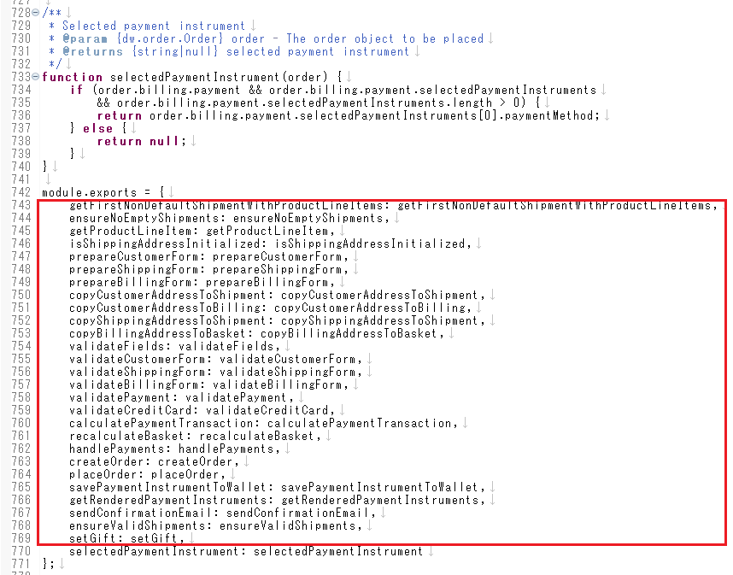

・[app_storefront_base]/cartridge/templates/default/checkout/billing/paymentOptions.isml

Add the below the first line of the file（after div.form-nav）and attribute in div.form-nav

...........................

**<isscript>**

**<isset name="paymentMethod" value="${require('*/cartridge/scripts/checkout/checkoutHelpers').selectedPaymentInstrument(pdict.order)}" scope="page"/>**

**</isscript>**

<div class="form-nav billing-nav payment-information"

data-payment-method-id="CREDIT_CARD"

**data-selected-payment-method="${paymentMethod}"**

data-is-new-payment="${pdict.customer.registeredUser && pdict.customer.customerPaymentInstruments.length ? false : true}"

>

...........................

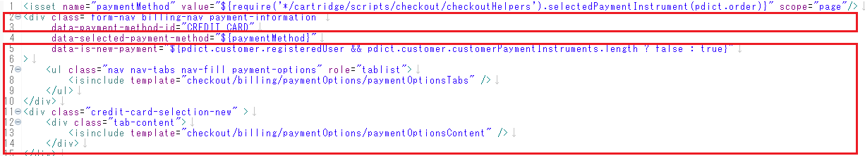

### 3-3-2. CheckoutJS installation

In order to process payment, the Checkout JS script is embedded in the payment page template.

Including this script will call Paidy Checkout.

To embed the template, modify the following file.

・[app_storefront_base]/cartridge/templates/default/common/layout/checkout.isml

Add the below after <head>

...........................

<!DOCTYPE html>

<html lang="en">

<head>

**<script type="text/javascript" src="https://apps.paidy.com/"></script>**

<!--[if gt IE 9]><!-->

...........................

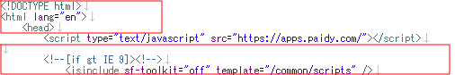

### 3-3-3. Added paidy.js loading

Add the payid.js required for the payment process below.

・[app_storefront_base]/cartridge/templates/default/checkout/checkout.isml

Add the below after assets.addJs('/js/checkout.js');

...........................

<isscript>

var assets = require('*/cartridge/scripts/assets.js');

assets.addJs('/js/checkout.js');

**assets.addJs('/js/paidy.js');**

assets.addCss('/css/checkout/checkout.css');

</isscript>

...........................

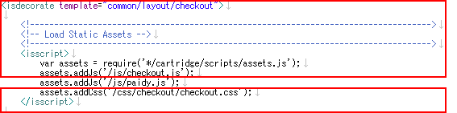

### 3-3-4. Add attribute on order confirmation button

Define the information required for the payment process as the attribute of the settlement confirmation button.

・[app_storefront_base]/cartridge/templates/default/checkout/checkout.isml

Add the below in button.place-order

...........................

<button class="btn btn-primary btn-block place-order" data-action="${URLUtils.url('CheckoutServices-PlaceOrder')}"

**data-get-paidy-standard-config="${URLUtils.url('PaidyStandard-GetPaidyConfig')}"**

**data-paidy-standard-fail-order="${URLUtils.url('PaidyStandard-FailOrder')}"**

**data-paidy-standard-place-order="${URLUtils.url('PaidyStandard-PlaceOrder')}"**

**data-get-paidy-subscription-config="${URLUtils.url('PaidySubscription-GetPaidyConfig')}"**

**data-paidy-subscription-set-token="${URLUtils.url('PaidySubscription-SetPaidyToken')}"** type="submit" name="submit" value="place-order">${Resource.msg('button.place.order', 'checkout', null)}

</button>

...........................

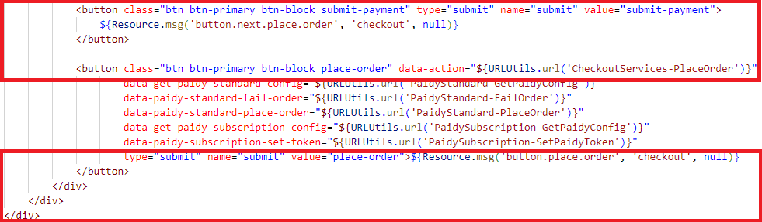

### 3-3-5. CheckoutServices.js modifications

Select Paidy as the payment method, and do not process credit card payment in Ajax processing when transitioning to the order confirmation screen.

・[app_storefront_base]/cartridge/controllers/CheckoutServices.js

Add the below.

...........................

server.post(

'SubmitPayment',

server.middleware.https,

csrfProtection.validateAjaxRequest,

function (req, res, next) {

(omission)

var validationHelpers = require('*/cartridge/scripts/helpers/basketValidationHelpers');

**var cartHelpers = require('*/cartridge/scripts/cart/cartHelpers');**

**var paidyHelpers = require('*/cartridge/scripts/paidy/paidyHelpers');**

var currentBasket = BasketMgr.getCurrentBasket();

(omission)

}

**paidyHelpers.resetPaymentForms(currentBasket);**

var billingAddress = currentBasket.billingAddress;

var billingForm = server.forms.getForm('billing');

...........................

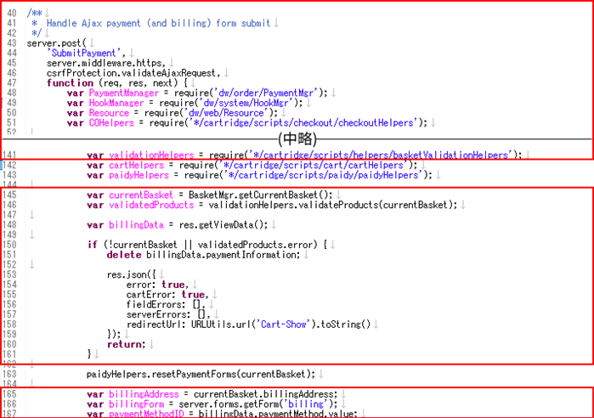

Add a process to be interrupted before proceeding the payment process when creating an order from Paidy with Ajax

Add the below.

...........................

server.post('PlaceOrder', server.middleware.https, function (req, res, next) {

var BasketMgr = require('dw/order/BasketMgr');

(omission)

var addressHelpers = require('*/cartridge/scripts/helpers/addressHelpers');

**var paidyHelpers = require('*/cartridge/scripts/paidy/paidyHelpers');**

var currentBasket = BasketMgr.getCurrentBasket();

(omission)

if (handlePaymentResult.error) {

res.json({

error: true,

errorMessage: Resource.msg('error.technical', 'checkout', null)

});

return next();

}

**if (paidyHelpers.isPaidyStandard(currentBasket.paymentInstrument.paymentMethod)){**

**var responseJson = require('*/cartridge/scripts/paidy/standard/authorize')**

**.getConfirmationPaidyJSON(currentBasket.paymentInstrument.paymentMethod, order.getCustomer(), order);**

**res.json(responseJson);**

**return next();**

**} else if (paidyHelpers.isPaidySubscription(currentBasket.paymentInstrument.paymentMethod)){**

**var paidySubscriptionAuthorize = require(**

**'*/cartridge/scripts/paidy/subscription/authorize')**

**.Authorize(order, req.querystring.paidyToken);**

**if (paidySubscriptionAuthorize.error) {**

**Transaction.wrap(function () { OrderMgr.failOrder(order); });**

**res.json({**

**error: true,**

**errorMessage: Resource.msg('error.technical', 'checkout', null)**

**});**

**return next();**

**}**

**}**

var fraudDetectionStatus = hooksHelper('app.fraud.detection', 'fraudDetection', currentBasket, require('*/cartridge/scripts/hooks/fraudDetection').fraudDetection);

...........................

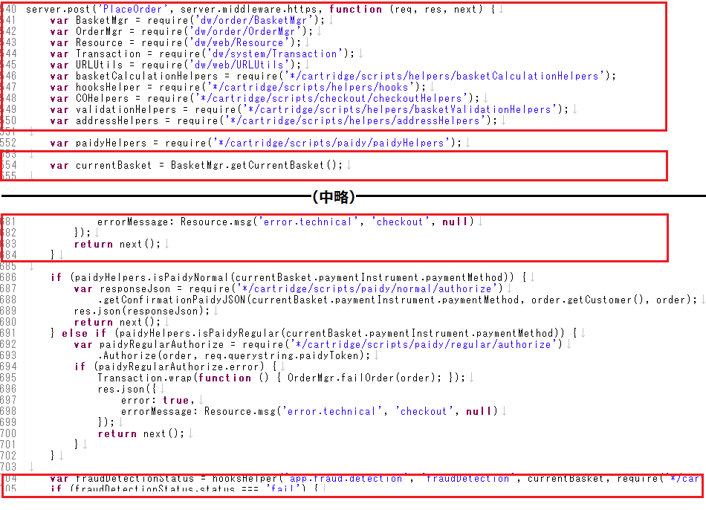

・[app_storefront_base]/cartridge/scripts/cart/cartHelpers.js

Add the below function.

...........................

(omission)

**/\*\***

**\* Deletes multiple payment instruments.**

**\***

**\* @transactional**

**\* @alias module:models/CartModel~CartModel/removePaymentInstruments**

**\* @param {dw.order.Basket} basket - the target Basket object**

**\* @param {dw.util.Collection} paymentInstruments - The payment instruments to remove.**

**\*/**

**function removePaymentInstruments(currentBasket, paymentInstruments) {**

**collections.forEach(paymentInstruments, function(item) {**

**currentBasket.removePaymentInstrument(item);**

**});**

**}**

(omission)

updateBundleProducts: updateBundleProducts**,**

**removePaymentInstruments: removePaymentInstruments**

};

...........................

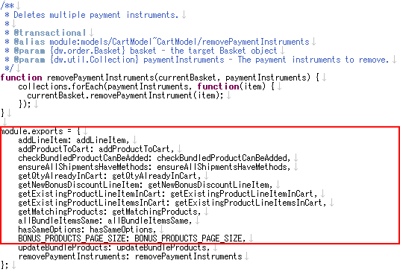

### 3-3-6. Add payment method to email template

Add a payment method to the email sent when payment is completed.

・[app_storefront_base]/cartridge/templates/default/checkout/confirmation/confirmationEmail.isml

Add the below after </isif> in isloop of Payment information

...........................

(omission)

<span>${Resource.msg('msg.card.type.ending', 'confirmation', null)} ${payment.expirationMonth}/${payment.expirationYear}</span>

</div>

</isif>

**<isif condition="${payment.paymentMethod === 'PAIDY_****STANDARD'}">**

**<isinclude template="checkout/billing/paymentOptions/paidyStandardSummary" />**

**</isif>**

**<isif condition="${payment.paymentMethod === 'PAIDY_SUBSCRIPTION'}">**

**<isinclude template="checkout/billing/paymentOptions/paidySubscriptionSummary" />**

**</isif>**

</isloop>

</div>

</div>

...........................

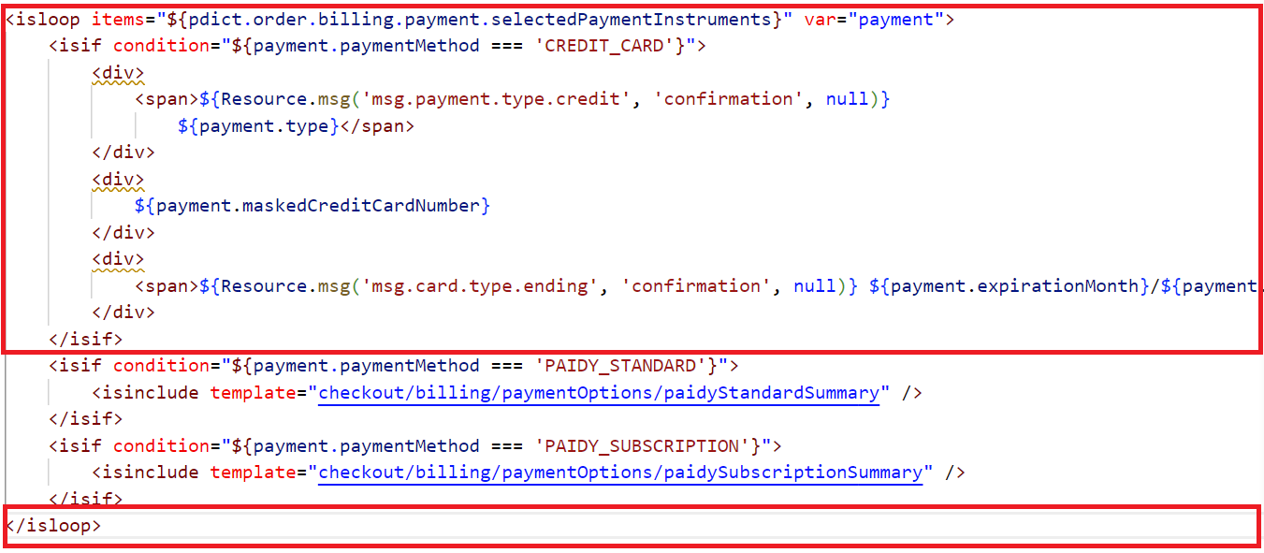

## 3-4. Advice

- Notes on use of subscription purchases

　If you followed the steps to add a payment method as indicated in section 3-3-1, by default, you will have two separate entries -- standard payments and subscription payments.

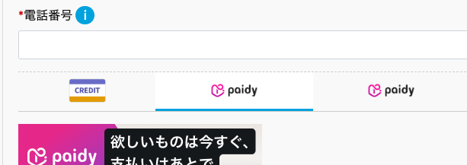

If there are means to detect whether subscription payments have been selected when transitioning to the payment selection screen, CSS or other means can be used to restrict the display to only show 「あと払い(ペイディ)」.

- Notes on tokens

int_paidy_sfra does not use PaidyToken for customer information.

Tokens can be checked via order data.

Merchant Tools > Order > Order > Order Numbers: Attribute

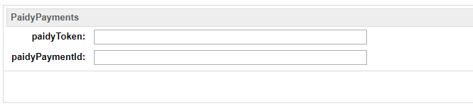

- Order confirmation e-mails for subscription purchases  
int_paidy_sfra cartridge is designed such that order confirmation e-mails are sent in the same manner as standard e-mails even for subscription purchases. To customize the e-mail sent, you can modify the int_paidy_sfra cartridge.

- Error message when a subscription payment is rejected

Please refer to the following wording for the message when a subscription payment is rejected.

------------------------------------------------------

今回の決済は承認されませんでした

申し訳ございませんが、オンラインショップが提供する他の支払方法をご利用ください。

なお、審査結果の詳細につきましては開示できませんのであらかじめご了承ください。

Paidyに関するお問い合わせ

0120-971-918

------------------------------------------------------

# 4. Cartridge deployment testing at merchant

## 4-1. Before beginning a test

### 4-1-1. Paidy merchant dashboard screen

- Confirming the test API key

Check the public and secret keys used for the test API; these will be entered into the custom site environment settings screen.



### 4-1-2.Commerce Cloud Business Manager

- API key settings

From the above settings screen, enter the test API keys you found for paidy_api_key and paidy_secret_key in section 4-1-1. Paidy merchant dashboard screen.

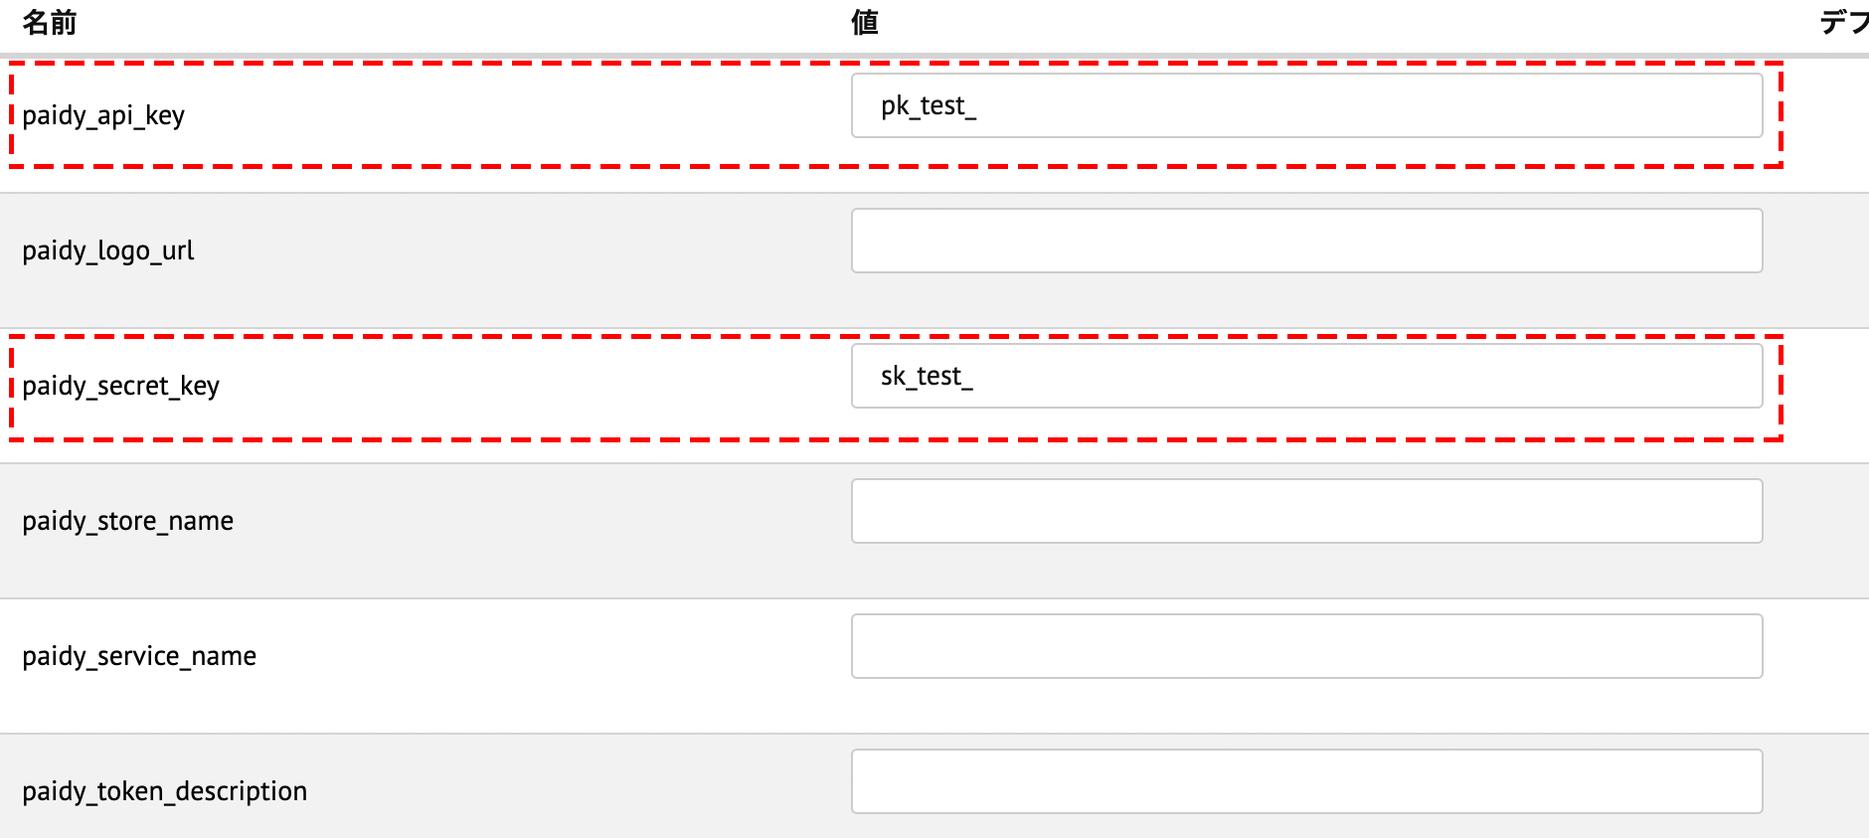

## 4-2. PaidyCheckout test data

-mail address and phone number

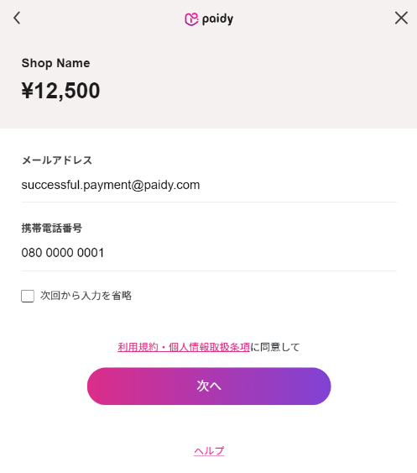 E-mail address and telephone usable for test cases

|  |  |  |
| --- | --- | --- |
| Test cases | mail address | phone number |
| Success | successful.payment@paidy.com | 080-0000-0001 |
| Failure | rejected.payment@paidy.com |

*Note that the e-mail address and phone number for the above member data and shipping and billing address can differ.

-Authentication number

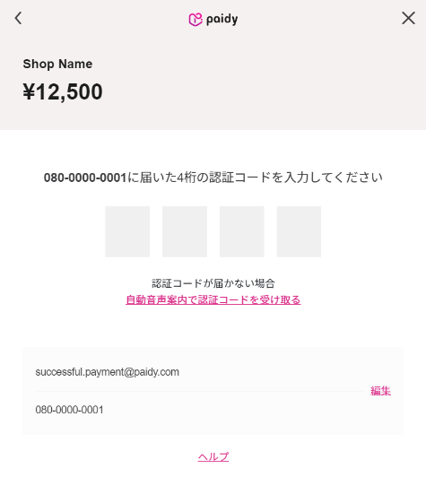Enter 8888

## 4-3. Browser compatibility

This cartridge supports the following OSes and browsers.

|  |  |
| --- | --- |
| Device - OS | Browser |
| PC - Windows | Edge: latest version |
| Chrome: latest version |
| FireFox: latest version |
| PC - MacOS | Chrome: latest version |
| Safari: latest version |
| Smartphone - iOS | iPhone (latest version of iOS) Safari  iPhone (latest version of iOS) Chrome |
| Smartphone - Android | Android4.4 and later, Chrome |

## 4-4. Test cases

Test cases to run after configuring the cartridge are listed below.

### 4-4-1. Paidy standard payments

Standard payment is tested using a guest and a member.

1. Successful order as guest

- If not logging in and selecting a payment method for Paidy standard payments, the PaidyCheckout popup appears. Entering a successful e-mail address and phone number will display the product purchase confirmation screen.

- The Commerce Cloud order number created on the Paidy merchant site should be displayed as a transaction ID

- The order status for the corresponding order number on Business Manager on Commerce Cloud will be new

2. Order success as member

- After logging in, when selecting a payment method for Paidy standard payments, the PaidyCheckout popup appears. Entering a successful e-mail address and phone number will display the product purchase confirmation screen.

- The Commerce Cloud order number created on the Paidy merchant site should be displayed as a transaction ID

- The order status for the corresponding order number on Business Manager on Commerce Cloud will be new

3. Failed order as guest

- If not logging in and selecting a payment method for Paidy standard payments, the PaidyCheckout popup appears. Entering a failing e-mail address and phone number will display an error message.

- The order status for the corresponding order number on Business Manager on Commerce Cloud will have failed

4. Order failure as member

- After logging in, when selecting a payment method for Paidy standard payments, the PaidyCheckout popup appears. Entering a failing e-mail address and phone number will display an error message.

- The order status for the corresponding order number on Business Manager on Commerce Cloud will have failed

### 4-4-2. Paidy subscription payments

Test as a member.

1. Success as a member

- When logging in as a member and selecting a payment method for Paidy subscription payments, the Confirm Order button is clicked and the PaidyCheckout popup appears. Entering a successful e-mail address and phone number and proceeding to processing the payment will display a product purchase confirmation screen

- The Commerce Cloud order number created on the Paidy merchant site should be displayed as a transaction ID

- The order status for the corresponding order number on Business Manager on Commerce Cloud will be new

2. Failure as a member

- When selecting a payment method for Paidy subscription payments and clicking the Confirm Order button, the PaidyCheckout popup appears. Entering a failing e-mail address and phone number and proceeding to processing the payment will display an error message

- The order status for the corresponding order number on Business Manager on Commerce Cloud will have failed

# 5. Webhook usage examples

## 5-1. Webhook usage

Paidy payments run credit holds for a purchase by means of communication directly between a consumer and Paidy over JavaScript. Therefore, one limitation of the system is that if the consumer bounces or the connection is cut, the e-commerce site may fail to obtain the results of payment confirmation and the stale payment data will remain on Paidy.

In the event of an inconsistency like the above, there are two problems.

1. The shop loses the opportunity to complete the order.

2. If the order does not have to be completed, the consumer has a credit hold placed against their Paidy account.

To accommodate these cases, a Webhook is provided.

The merchant can use the Webhook to detect inconsistent payments.

## 5-2. Detecting inconsistent payments

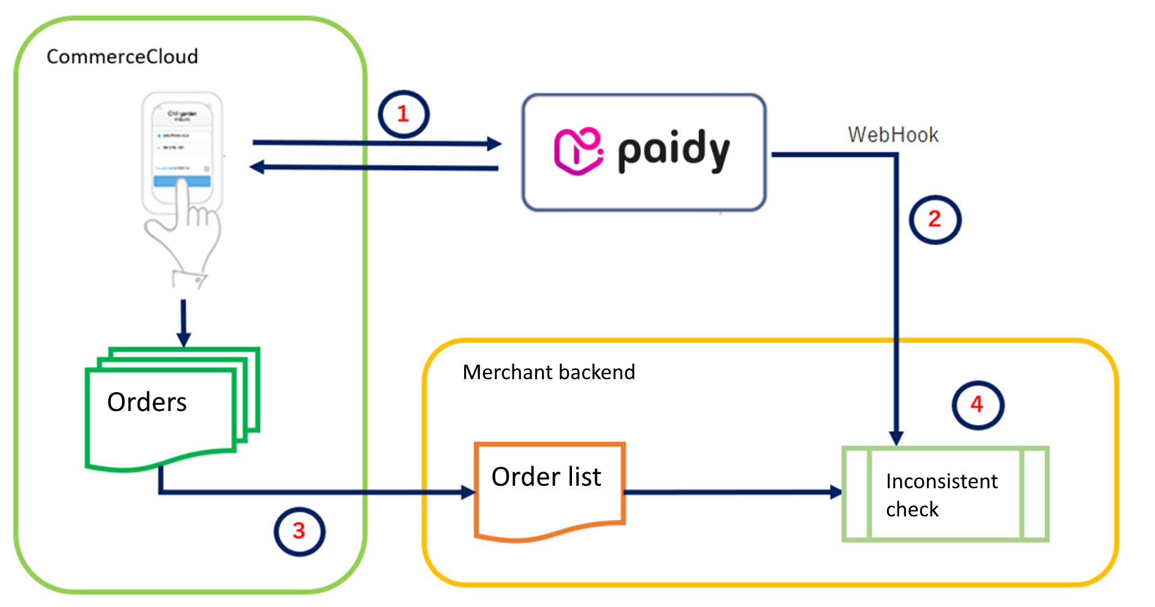

1. Payment

Payment is made via Commerce Cloud using Paidy. A callback from Paidy’s payment results returns one of the three order statuses below.

- Payment success: New Outputted to the order list. Payment possible status

- Payment failure: Failed Not outputted to the order list. Payment not possible status

- Processing: Created Not outputted to the order list. When in a payment not possible status, updating the payment transitions to a payable status.

2. Webhook

Setting Webhook endpoints on the merchant backend allows for receiving notifications from Paidy of payment completion.

3. Order list

A list of successful orders processed through batch processing on Commerce Cloud is sent as an xml file to the merchant’s backend.

4. Inconsistent payment check processing

Checks for payments where Webhook data (2) is found, but no payment data (3) exists on Commerce Cloud.

## 5-3. Handling inconsistencies

Inconsistent payments that have been detected can be handled as follows, allowing for resolving the above issues.

### 5-3-1. Processing example 1

In this solution, a list of inconsistent/invalid payments is outputted and can be checked by the merchant.

After a check is performed, the necessary steps are taken (approving or cancelling payment).

1. Establishing payment

Use the Order function on Business Manager on Commerce Cloud to update the status.

- General tab

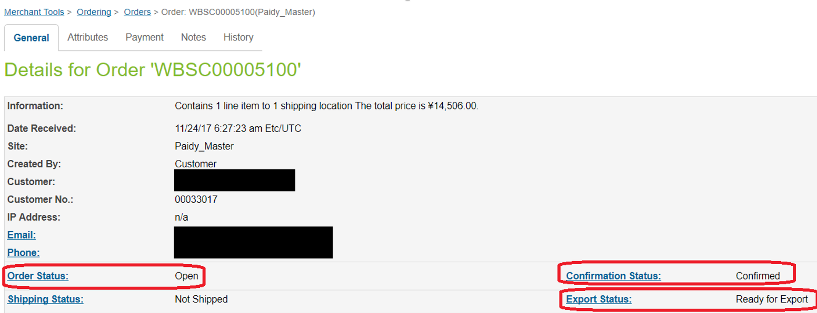

The status of the above three points is changed per below

Order Status：Created→Open

Confirmation Status：Not Confirm→Confirmed

Export Status:Not Exported→Ready for Export

・Attribute tab

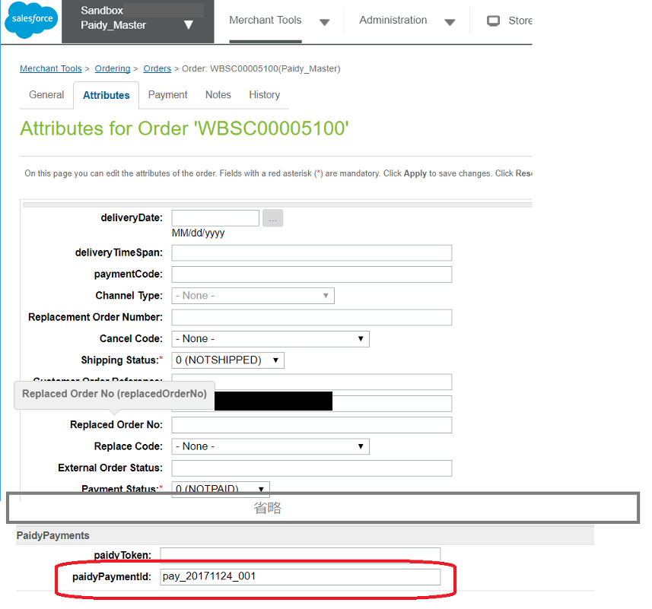

Set the paidyPaymentID that arrived via the Webhook for paidyPaymentId

*In order to e-mail an order confirmation e-mail as you would with StoreFront, it must be customized, as the format differs (see below).

- Order confirmation e-mail (concept)

■SiteGenesis StoreFront e-mail (normally used e-mail)

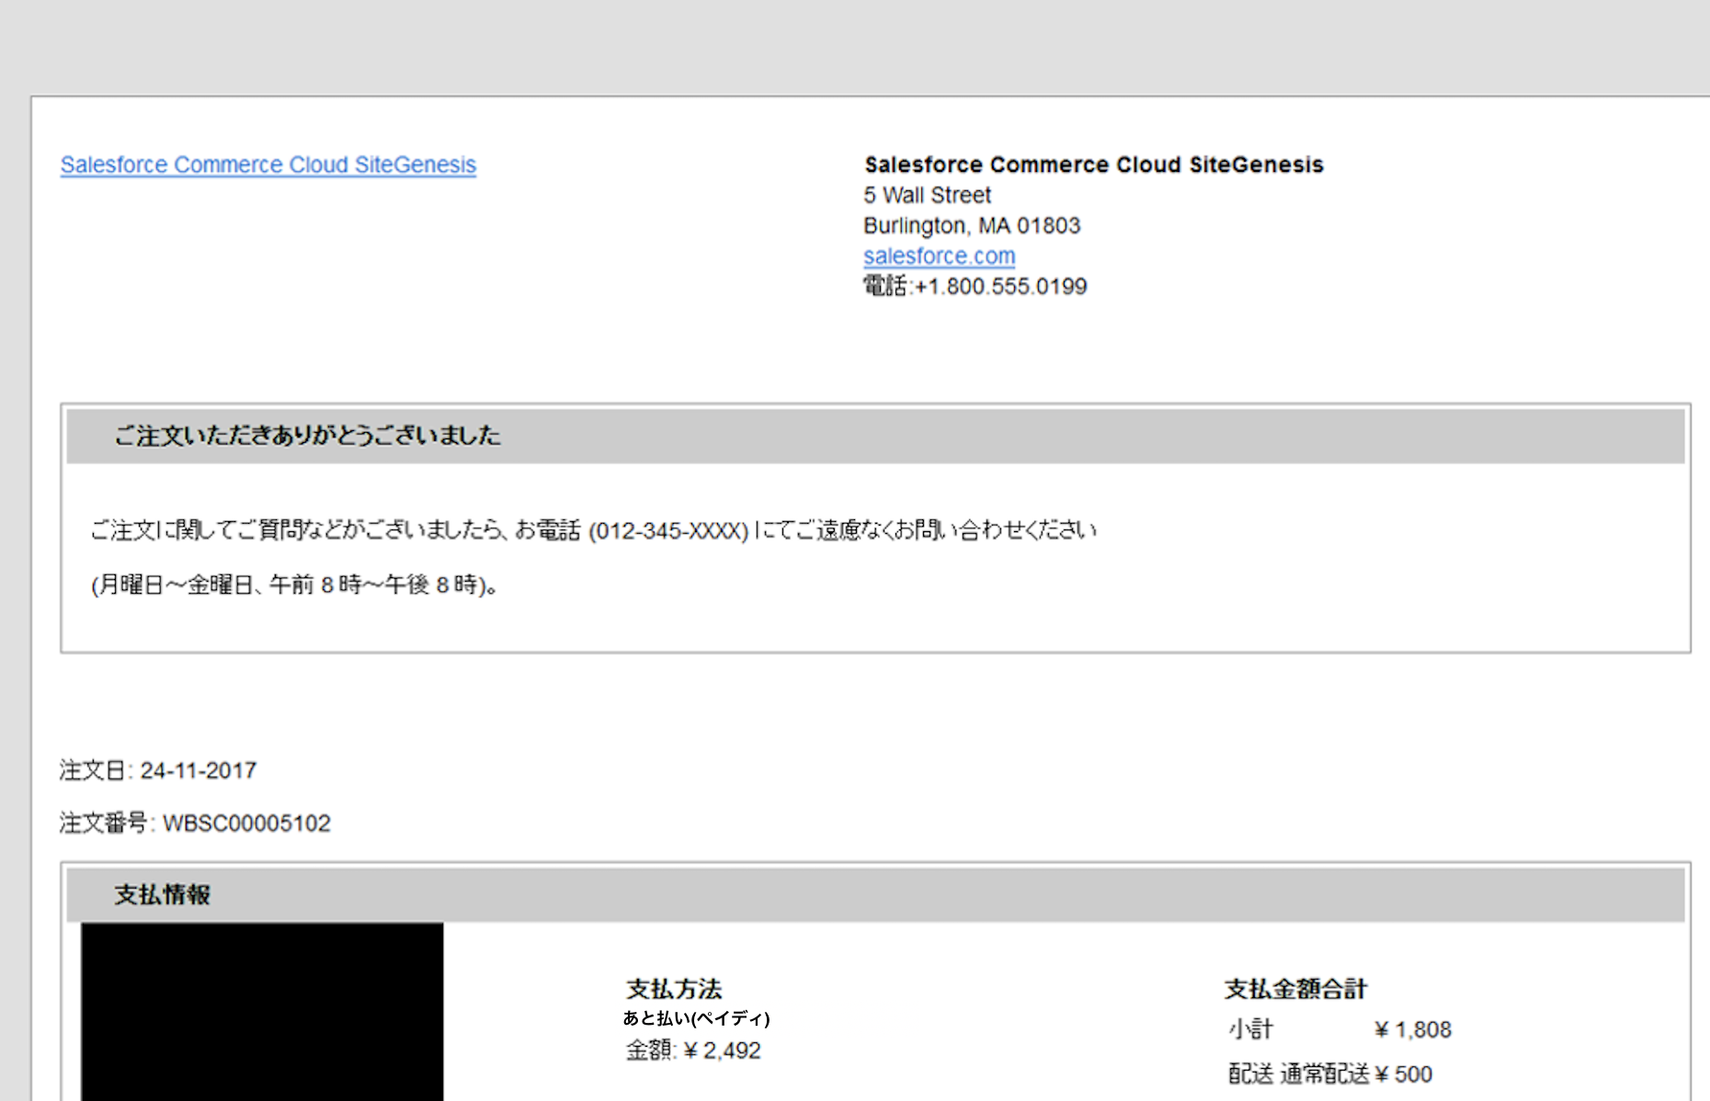

■E-mails sent from SendMail button on bottom of General tab on BusinessManager > Orders

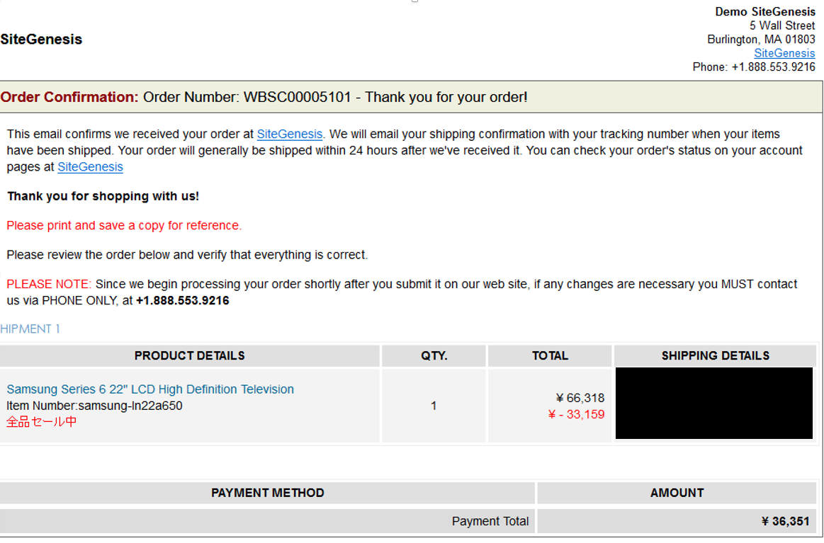

2. Cancelling payments

Displaying the transaction in question on the Paidy merchant management screen and Canceling it (do not capture and close).

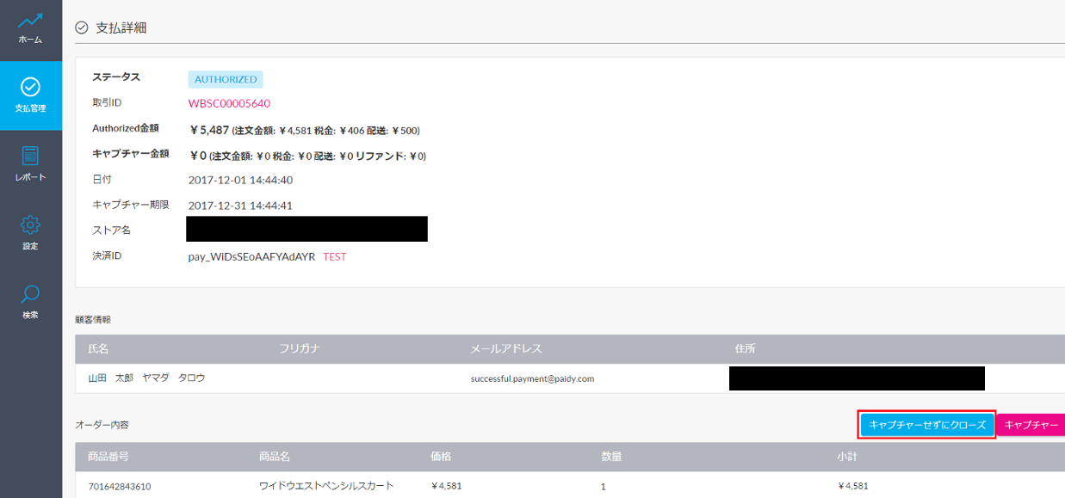

### 5-3-2. Processing example 2

In this example, the system makes a determination and automatically cancels inconsistent payments.

If, after referencing the order data and Webhook data on Commerce Cloud, the payment does not complete on Commerce Cloud, and authorization data is found only on Paidy, the close API is requested and the payment is closed.

<https://paidy.com/docs/jp/payments.html#close>

## 5-4. Webhook settings

In order to receive notifications from Paidy on the backend, the Webhook URL must be saved to the Paidy merchant management screen settings.

URL: https://merchant.paidy.com

You can enable these settings for a live environment by setting the merchant’s live backend URL in the Webhooks: Live API Key and Old Version API Access Key sections.

In order to check connectivity with test payments before configuring the live environment, set the merchant’s backend test URL in Webhooks: Test API Key.

Paidy merchant management screen

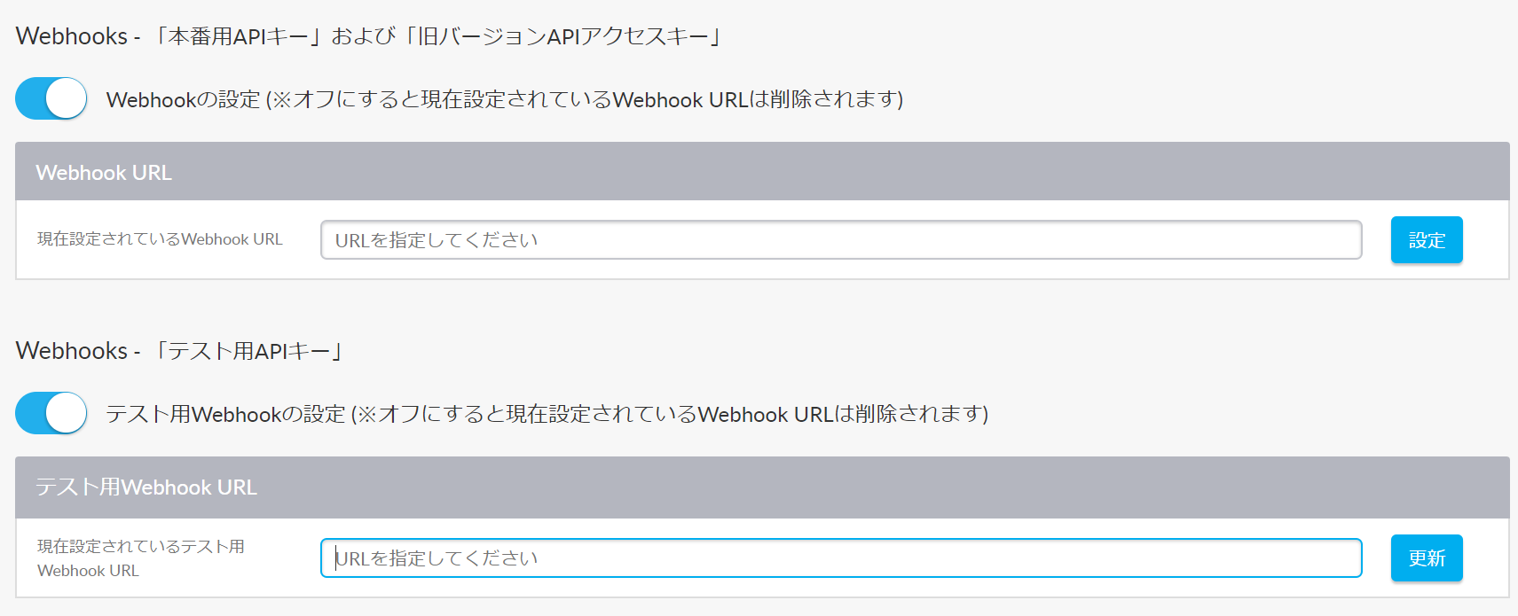

# 6. What to do when the service is down

・what happens when the service is down

If you select Paidy payment, you will get an error screen or the pop-up will stop working.

・what the merchant should do to fix it

To get started, please contact Paidy Technical Support.

Paidy Technical Support

Mail: tech-support@paidy.com

TEL : 03-5545-5099 (weekdays 10:00-18:00)

If it takes a time to recover, please set the enable flag for paidy_enabled to "いいえ(No)" in the Custom Preferences.

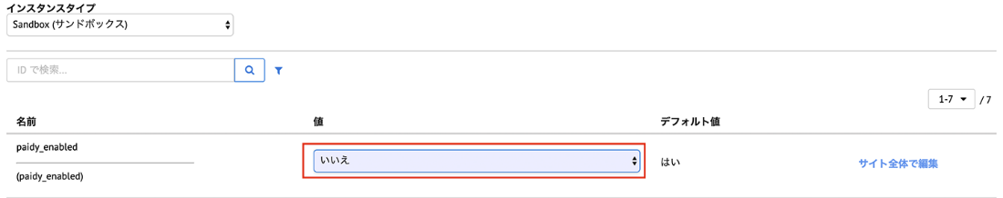

# 7. Revision history

|  |  |  |
| --- | --- | --- |
| Version | Date | Revisions |
| 1.1.0 | 2019/12/06 | First edition |
| 20.1.0 | 2020/01/15 | 3-2-2. Importing metadata  -Modify 「meta_data_19.1.0.zip」to「meta_data_20.1.0.zip」 |
| 20.1.0 | 2020/4/5 | -SFRAのバージョン情報を追記。  -Business Managerの互換モードを記載。  -Add Version of SFRA and Compatibility Mode  -Add 6. What to do when the service is down |
| 21.1.0 | 2021/6/21 | -Update 1. Cartridges version update  -Update 4.SFRA support version update  -Update 16-17. int_paidy postscript  -Update 18. Import meta file name update  Deleted description related to SiteGenesis and common metafile  -Update 25. Corrected the description of function felected Payment Instrument  - Update 31. Embedded code fix  -Removed 35. Deleted the description of package.json |
| 22.1.0 | 2022/6/21 | p.1  update version in cover  all pages  Modified normal payment ID andsubscription ID, as follows.   * normal -> standard * regular -> subscription   p.4  updated supported store Front Reference Architecture and compatibility mode version  p.17  update import meta file name  p.37  4-3. Removed IE11 from Browser compatibility |
| 22.1.1 | 2022/11/24 | All pages  The following modifications were made due to the change in the name of Paidy standard and subscription payment service.   * standard payment   あと払い (ペイディ)   * subscription payment   あと払い (ペイディ) ※定期購入  ●支払方法説明  ・クレジットカード、事前登録不要。  ・メールアドレスと携帯番号だけで、今すぐお買い物。  ・1か月に何度お買い物しても、お支払いは翌月まとめて1回でOK。  ・お支払いは翌月10日までに、コンビニ払い・銀行振込・口座振替で。  ペイディについて詳しくはこちら。  Capture was changed to reflect the above changes. |